

DAT602 Assessment Project

Assignment 2 Project

Author: Shinn KRAMMER | Course: DAT602 | Tutor: Todd Cochrane

Includes:



<https://www.adobe.com/nz/products/xd.html>

<https://www.visual-paradigm.com/>

<https://www.mysql.com>

Table of Contents

SKETCHES plus SQL for the game. 2

HAND OUT DATE: 22nd February 2021 2

HAND IN: as specified in the course outline 2

Milestone one is made up of 80 marks worth 25% of the total marks. 2

Abstract 2

1. Game Description 3

1.1. base idea 3

1.2. Logging In 3

1.3. game lobby 3

1.4. gameplay 3

1.5. administration 3

2. Storyboards 4

2.1. Screen design rationale 10

3. Entity Relationship Diagram (ERD) 11

3.1. Entity Relationship Diagram Rationale 12

4. CRUD Table (Create, Read, Update, Delete) 13

4.1. CRUD Analysis 14

5. SQL 14

5.1. DDL 14

5.2. Test DATA QUERIES 14

MILESTONE ONE

# SKETCHES plus SQL for the game.

### HAND OUT DATE: 22nd February 2021

### HAND IN: as specified in the course outline

### Milestone one is made up of 80 marks worth 25% of the total marks.

# Abstract

asdf

# Game Description

## base idea

The idea for the game is a multiplayer point and click Collect-A-Thon top down grid view Adventure Game. Players move one tile at a time by clicking on their neighboring tile. The game takes place in space where the player takes the role of an astronaut collecting tools that have floated away from their ship. Players gain points by collecting more tools. There score is accumulated and saved to their profile.

## Logging In

On starting the game, the player is greeted with a login screen. The user can log in to the game by inputting their username and password. If the account already exists, the player is logged in. If the username is not detected, then a warning will pop up saying that they are about to start a new player. Once a password is made and the login button is pressed then the new player is registered.

## game lobby

The game will have a game lobby menu. It will list all the active games that are online with the hosts name being the title for these games. The player can join an online game or host their own game and have other online players join.

## gameplay

The player will have a character on a grid tile. The first tile the character is on is titled the home tile. To gain points the player must navigate the grid of tiles by pointing and clicking (point and click) on the neighboring tiles of the character and collecting the items scattered across the map. The items when collected add to the score and different items have different scores.

## administration

Administrators will have their own screen. On the game lobby menu screen there are more options. These options include stopping active games, adding a new player, updating player information and removing existing players.

# Storyboards

**Storyboard 1 – login screen**

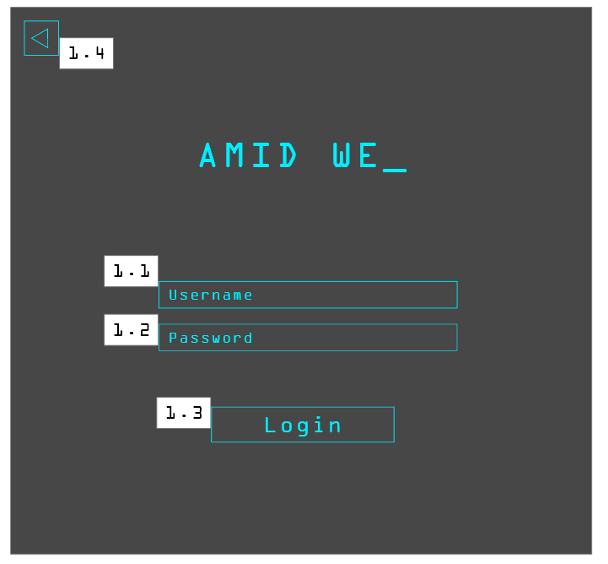

* 1. Username textbox

if username belongs to existing account and password is correct then go to game menu SB3

if username is new then pop-up warning 2.1

1.2 Password textbox

If password is wrong after 5 tries, then the account gets locked – admin email pops up 2.2

1.3 Login Button

1.4 Exit Button

**Storyboard 2 – New Account**

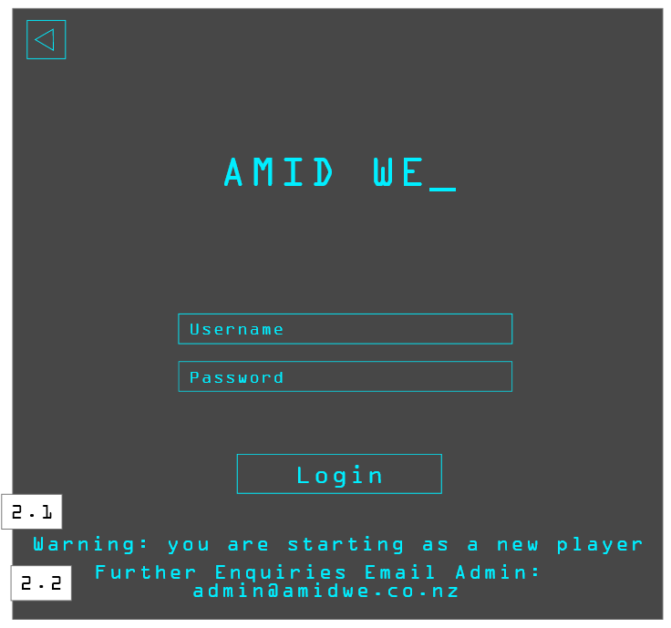

2.1 Warning Message

2.2 Admin Email

**Storyboard 3 – Menu**

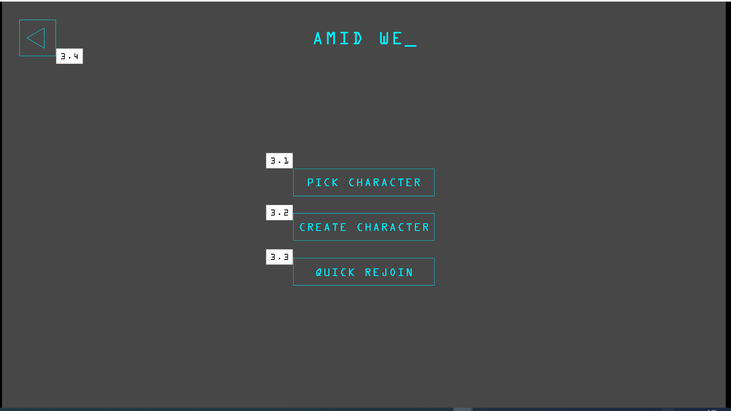

3.1 Pick Character Button

3.2 Create Character Button

3.3 Quick Rejoin

3.4 Back to Login Button (logout)

**Storyboard 4 – Pick Character**

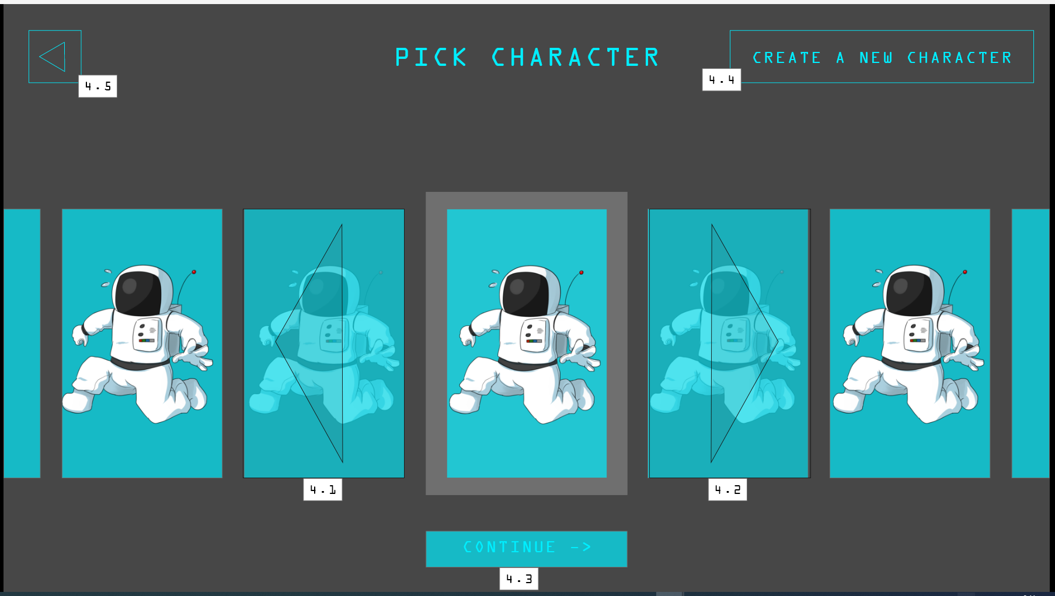

4.1 Left Slide button to select already existing character

4.2 Right Slide button to select already existing character

4.3 Continue Select Character Button

4.4 Create New Character Button (Takes to SB5)

4.5 Back to Menu button (Takes to SB3)

**Storyboard 5 – Create Character**

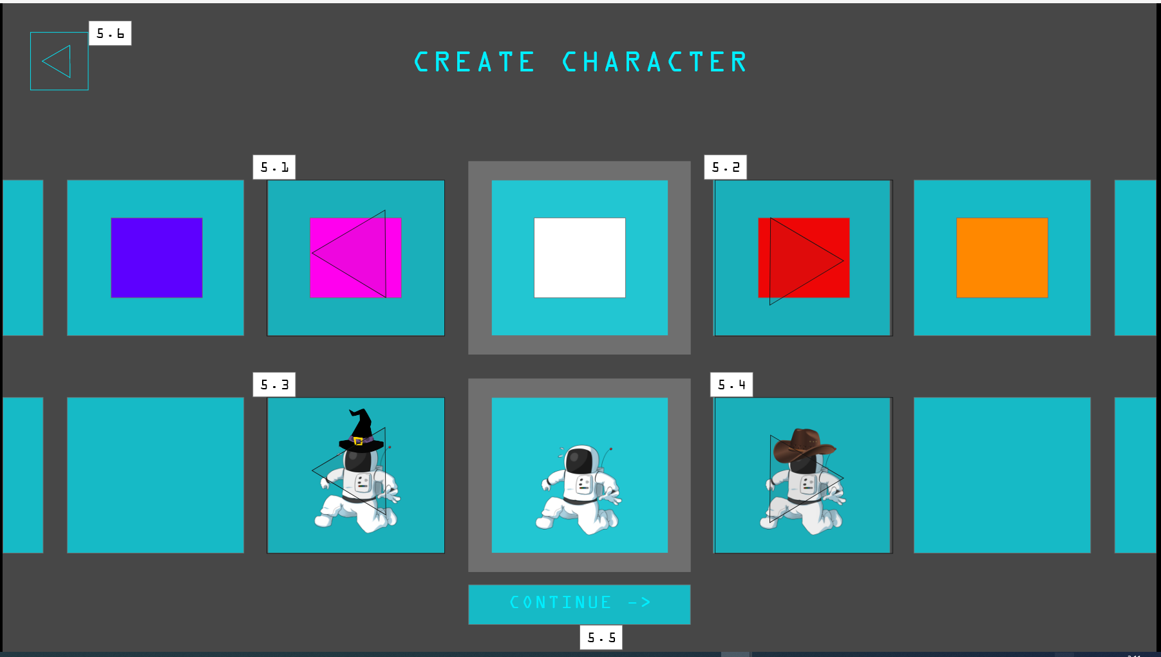

5.1 Left Slide button to select Colour

5.2 Right Slide button to select Colour

5.3 Left Slide button to select Hat

5.4 Right Slide button to select Hat

5.5 Continue Button to Create Character Combination (Goes to SB6)

5.6 Back to Menu Button (Goes to SB3)

**Storyboard 6 – Lobby Screen**

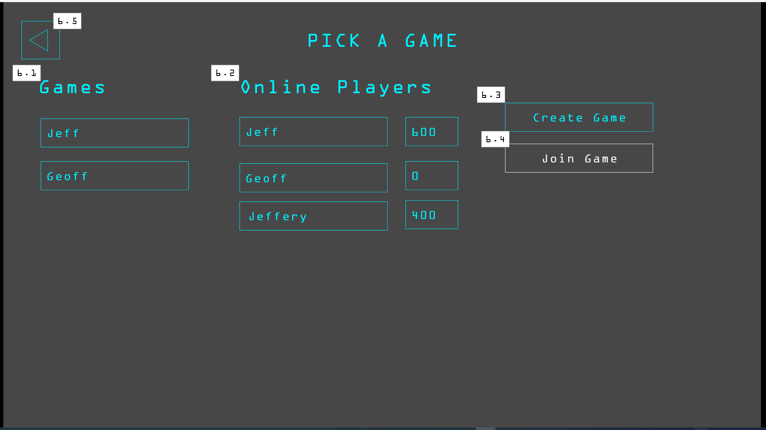

6. 1 Games listed with host Name

6.2 Online Players Listed with Scores

6.3 Create Game Button

6.4 Join Game Button which becomes Clickable when Game is selected

6.5 Back to Menu Button (Goes to SB3)

**Storyboard 7 – Admin Lobby Screen**

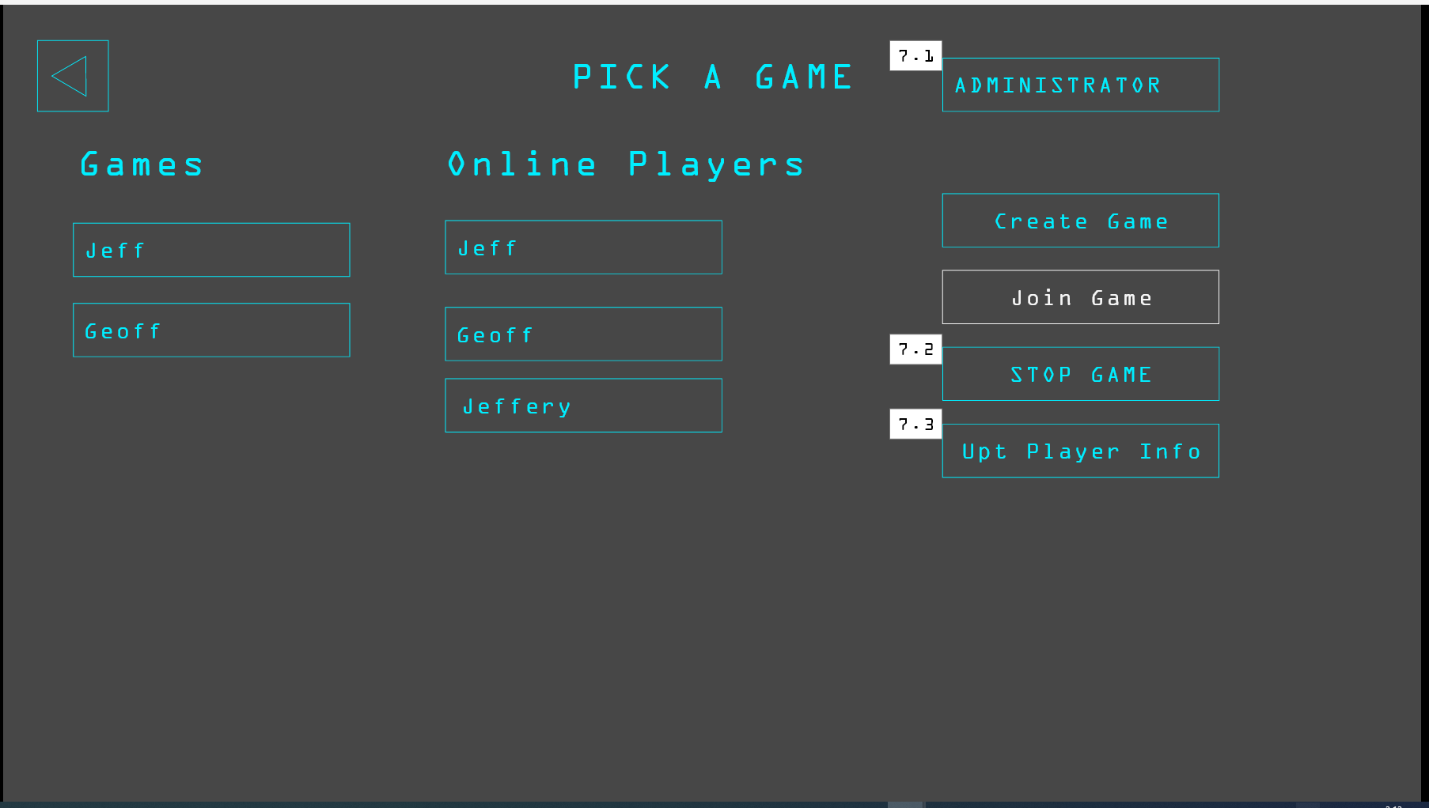

7.1 Admin Title

7.2 Stop Game Button

7.3 Update Player Info (Goes To Admin Update Screen SB8)

**Storyboard 8 – Admin Update Screen**

Not done

**Storyboard 9 – Game**

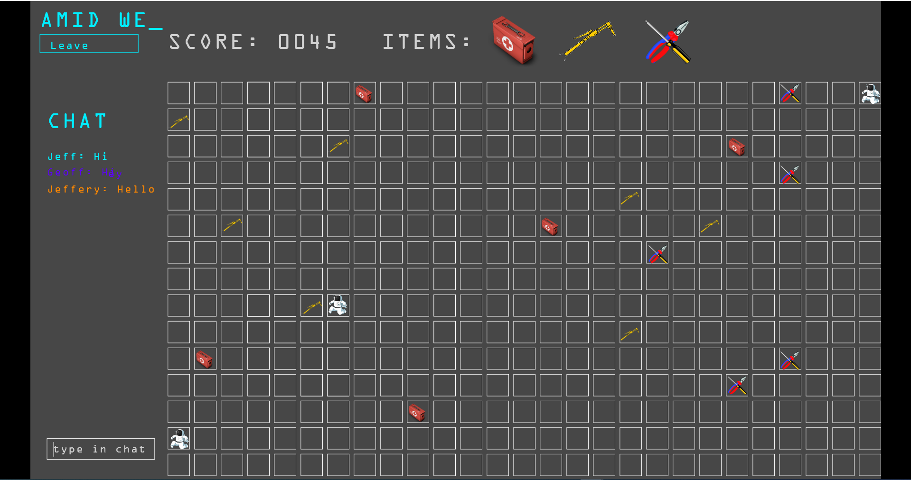

## Screen design rationale

Asdf

# Entity Relationship Diagram (ERD)

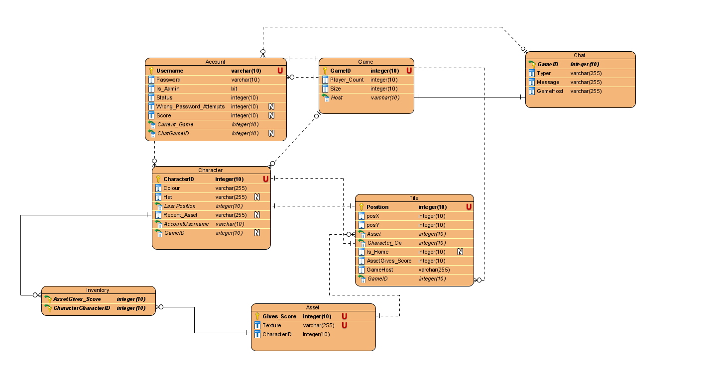

## Entity Relationship Diagram Rationale

# CRUD Table (Create, Read, Update, Delete)

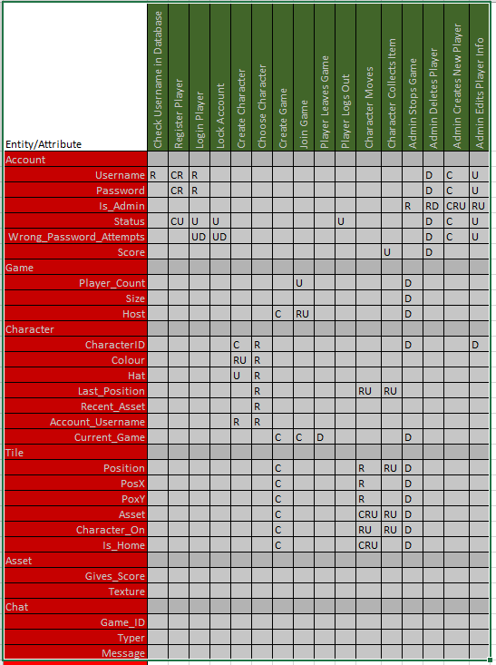

## CRUD Analysis

Asdf

# SQL

Milestone1.sql

## DDL

Asdf

## Test DATA QUERIES

Asdf